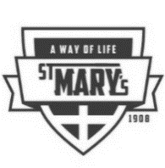
#10 NEWSLETTER for 2020-2021 School year
St. Mary’s Parish School
Week of Nov. 1, 2020

Questions this week:
#1 Is it true every student needs a non-spillable water bottle?
YES! There have been several students who have come to school without a water bottle. It really is important that students stay hydrated during school. We have purchased for each classroom water dispensers from Culligan. We have given away ALL the water bottles we had in storage. Please be sure your child has a water bottle with spill proof top (put your child’s name on it too). Students in K, 1, 4, 5 and 6 are missing water bottles.

#2 May shorts be worn in school?
No, the last day until spring 2021 was Oct. 28

#3 Can we still turn money in for JOG prizes?
Monday, November 2nd is the deadline for all monies/pledge sheets.

#4 Is there really a Pizza lunch for the WHOLE school?
Yes, it is for ALL students in ALL grades at NO cost. Let us know if your child needs a gluten free pizza by telling your child’s teacher or calling the school office on/by Nov. 10.

#5 Will the whole school have a Bingo party too on Fri. Nov. 13?
Due to numbers we may hold the “party” in two stages, but all will have a “bingo party”.

#6 Is our uniform company, Schoolbelles, ready to receive our orders?
Yes…please do it as soon as possible.

Peyton Dimmick and her family!
We are happy you are with us in grade four.

We want to remember our staff
who have celebrated gift of life so far this school year: Ariel Oliveira, aide, Sept. 29-----Rasheen Acree, Business Manager, Sept. 30
In November: Peggy Quesnell, Grade 2, Nov. 2----Debbie Johnson, Secretary, Nov. 3 and
Nicole Asker Grade 1, Nov. 18
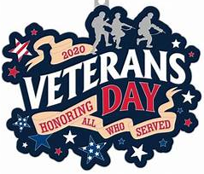
Veterans Day is Wednesday, November 11th. We would like to collect pictures (with a written paragraph about some information about the person(s) in the picture). We want to make a display in school. Also, we’d like to do an article on our FACEBOOK page. If you don’t want your information published, please include that with your information. Please send your picture(s) plus information to: Taylor Bierker’s email: sms678@stmarysmoscow.org
Will be organizing the information. Thank you Taylor for doing this! If you would like to bring a paper copy, please give to the school office with Taylor’s name on it. We want our students to understand and appreciate for all men and women who have given service to others via the armed forces.

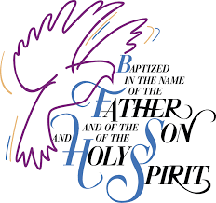
Blessings on Matt and Becky Couch family on the recent baptism
of their youngest daughter, Jaela Catherine.

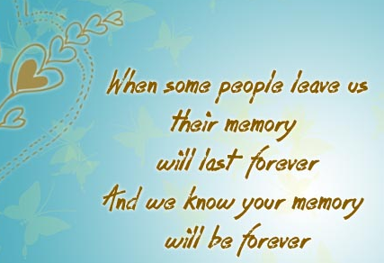
The good news is Josh and Heidi Evans Family have found a home they have been looking for their family. The sad news it’s in Palouse, WA. They moved there this past weekend. We wish them many blessings and we definitely will miss their daughter, Lillian (first grade).

FYI: This week students in Grades 7 and 8 will be taking The National Math Test Amc8. Good luck to our students!

Mass this Friday November 6 at 9:00 a.m. in the school gym. Grade 3 are the prayer leaders. Parents are welcome to attend. Face masks and social distancing are required, as always.

Did you know? A COVID-19 Carrier has an incubation period of up to 14 days. Carrier spreads COVID without knowing s/he is sick with the disease
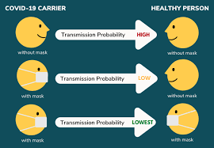

70% probability w/ NO mask

5% probability w/mask to no mask healthy person

1.5% probability when BOTH wear masks!!!!

On election day, Nov. 3, these year---thousands of women religious (nuns) from across the USA are praying around the clock for our country. The prayer they are praying is the following. We invite you to pray with them too by praying this together as your family, perhaps at dinner
.
“God of all, in this year of election, in these days of discernment, IGNITE us with the fire of your love. ENFLAME our hearts with courage to embrace dialogue that transforms and truth that frees. KINDLE our love with kindness to heal divisions and reconcile relationships. LIGHT our imaginations with insight to envision and create a world where all are one. STIR our actions with justice and peace to engage critical concerns and cherish all of life. FIRE our lives with audacity and hope to risk all for God’s mission.” Created by Notre Dame Sister Roxanne Schares, SSND

IGNITING faith, knowledge, creativity and service

